Food Document
Student Name
Institutional Affiliation
Due Date

Introduction
Caloric value can be defined as the amount of energy that is contained in a certain food. It can also be the amount of energy produced when 1 kilogram of a food substance is burnt in the presence of oxygen and the products cooled to STP (Harris et al.1918). The SI unit for caloric value is KJ/kg. Caloric value is calculated by dividing the calories of a food from fat by the total calories and multiplying by 100.
16/04/2021, breakfast at 6:30AM
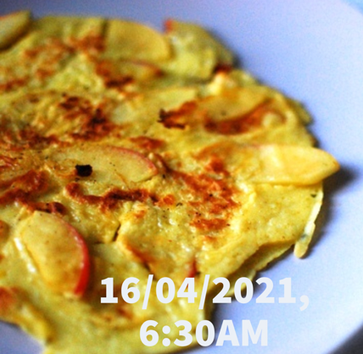

On 16/04/2021 I had pancake as my breakfast. My one pancake contained 100 calories. Aerobic (water) exercises will be used to burn these calories. 15 minutes running, 15 minutes jumping, 15 minutes dancing and 15 minutes swimming will burn 101 calories in 60 minutes.
16/04/2021, lunch at 12:00Noon
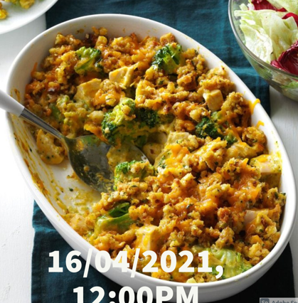
On 16/04/2021 I had broccoli chicken casserole for my lunch. A cup of my cooked broccoli consisted of 31 calories and 100g of chicken contained 239 calories. I consumed a total of 270 calories. Example of an exercise that can be used to burn the 270 calories is Golf (carrying/polling clubs) whereby 272 calories in 30 minutes.
16/04/2021, snack at 4:00PM
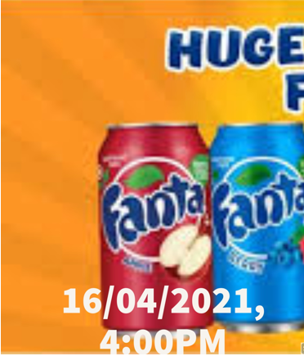
In the evening, I took fanta as my snack. My 300ml fanta soda contained 150 calories. Stationary cycling will help burn 158 calories in 30 minutes.
16/04/2021, dinner at 7:10PM
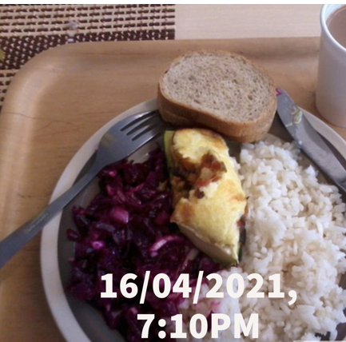
On my dinner I took white rice, purple cabbage, beef and bread. My 100g of cooked rice consisted of 121 calories, my 100g of purple cabbage contained 31 calories, and 3 ounces of beef contained 160 calories and my 2 slices of bread contained 64 calories. I consumed a total of 216 calories. These calories will be burned by swimming (fast freestyle) which will burn 218 calories.

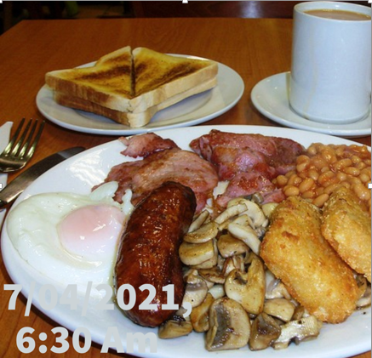
17/04/2021, breakfast at 6:30 AM

My first breakfast consisted of two slices of toasted bread which contain 129 calories, half cup of beans has 122 calories, one sausage has 100 calories, one egg has 78 calories, 1 slice of cooked bacon has 43 calories and 100g of mushroom has 22 calories. The total number of calories that I consumed was 494 calories. The exercise to burn these calories will include running (10 mi, mild) to burn 315 calories and tennis (singles) for 30 minutes to burn 180 calories. The total number of burnt calories will be 495 calories for 40 minutes.
17/04/2021, lunch one at 12:00 noon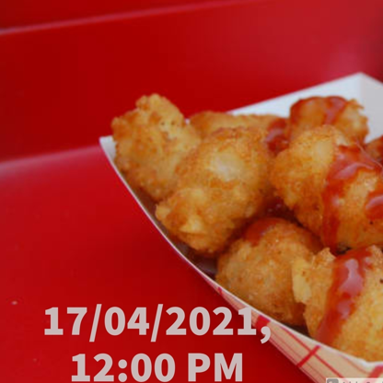

The lunch I took on 17/04/2021 was tater tots which had 74 calories in 4-ounce serving. They type of exercise I need to burn these calories is walking (slow-2MPH) which burns the 74 calories in 30 minutes.
17/04/2021, snack at 4:00 PM
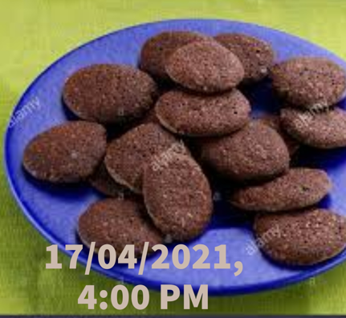
On 17/04/2021 I took a snack at 4:00PM. Chocolate icebox cookies have 210 calories in one serving. The type of exercise required to burn these calories is weigh training (15 minutes of barbell squat, 15 minutes of hack squat, 15 minutes of bench press and 15 minutes of dumbbell military press). These will burn 216 calories in 60 minutes.
17/04/2021, dinner, 7:10PM
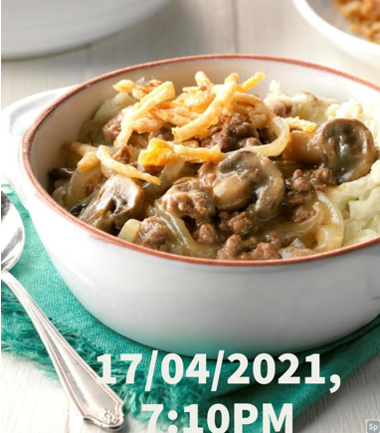

On my 17/04/2021 dinner, I ate beef and mushroom and smashed potato. My 3 ounces of beef contained 160 calories, 100g of mushroom had 22 calories and 100g of potatoes consisted of 77 calories. In total I consumed 259 calories. These calories can be burned through swimming (fast freestyle) to burn 218 calories and walking (slow-2MPH) to burn 61 calories. In total 279 calories will be burned.
Conclusion
Calories can be burned through different ways including exercising. Different kinds of exercises burn different amounts of calories. Examples of these exercises include aerobics (light, vigorous and water aerobics), bicycling, golf, karate, racquetball, rowing, running, stationary, swimming, tennis, walking and weight training.

References
Harris, J. A., & Benedict, F. G. (1918). A biometric study of human basal metabolism. Proceedings of the National Academy of Sciences of the United States of America, 4(12), 370.

